**BUC GE Centricity Business to GE Centricity IDX**

**ADT Requirements**

**Version 1.01**

**Prepared By: Art Schwartz**

**Date: 10/13/2016**

Document Control 3

Resources 3

Project Distribution List 3

Document Version Control 3

1. Introduction 4

1.1 Purpose 4

1.2 Project Scope 4

1.3 Terminology Standards 4

1.3.1 Acronyms 4

1.3.2 Glossary 4

1.4 Document References 4

*2.* Diagram 5

3. Requirements 6

3.1 Functional Requirements (Cerner FSI) 6

3.2 Non-Functional Requirements 6

3.3 Messaging Protocols 7

3.3.1 Inbound to the BayCare Cloverleaf 7

3.3.2 Outbound to the BayCare Cloverleaf 7

3.3.3 Inbound to the Vendor 7

3.3.4 Outbound to the Vendor 7

4. HL7 Messaging 8

4.1 Messaging Format 8

4.1.1 Segments 8

4.1*.*2 Messaging Event Types 8

4.1*.*3 Cloverleaf Configuration Files 8

4.1.4 Cloverleaf Site Location 8

4.2 Data Transformation Requirements 9

4.3 Sample Messages 12

5. Testing 14

5.1. Unit Testing Scenarios 14

5.2 Integrated Testing Scenarios 14

5.3 Testing Approvals 14

5.4 Piloting 15

5.5 Approvals 15

6. Deployment / Implementation Model 16

Appendix A: Risks and Concerns 17

Appendix B: Issues List 18

# Document Control

## Resources

|  |  |  |
| --- | --- | --- |
| **Name** | **Role** | **Email** |
| Sarah Thies | BayCare Integration Analyst | Sarah.Thies@baycare.org |
| Art Schwartz | BayCare Integration Analyst | Art.Schwartz@baycare.org |
| Daniel Alicea | Manager, IS Physician SYS-EPM/GE | Daniel.alicea@baycare.org |
| Cindy Barone | Supervisor Clinical Systems | Cynthia.Barone@baycare.org |
|  |  |  |

## Project Distribution List

## Document Version Control

|  |  |  |  |
| --- | --- | --- | --- |
| **Version** | **Date** | **Modifier** | **Description** |
| V1.0 | 10/10/2016 | Lois Whitley | Originally Created |
| V1.1 | 10/13/2016 | Art Schwartz | Added Cloverleaf Mapping |
|  |  |  |  |
|  |  |  |  |

# 1. Introduction

## 1.1 Purpose

This document outlines the BayCare Urgent Care (BUC) Admission, Discharge, Transfer (ADT) interface from GE Centricity Business to GE Centricity IDX (aka RIS). All functional requirements needed to support this solution post implementation will be included.

## 1.2 Project Scope

Implement an ADT interface from the GE Centricity Business Practice Management System to the GE Centricity IDX Application for the BayCare Urgent Care (BUC) providers.

## 1.3 Terminology Standards

### 1.3.1 Acronyms

ADT – Admission, Discharge, Transfer

GECB – GE Centricity Business

PCP – Primary Care Provider

RIS – Radiology Information System

### 1.3.2 Glossary

List the terms that require definition

## 1.4 Document References

**GE Specifications:**

MASTER BYH_ADT_Reg_VM_FINAL

# *2.* Diagram

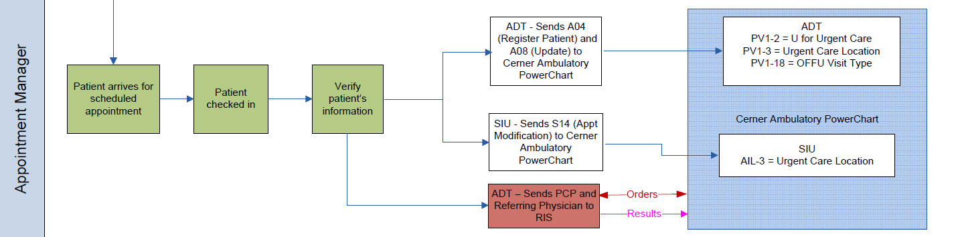

# 3. Requirements

## 3.1 Functional Requirements (Cerner FSI)

Provide detail for the below functional requirements. The message transformation requirements for the components defined in this specification should be specified in section 4.2 of this document.

|  |  |  |
| --- | --- | --- |
|  |  |  |
| **Cerner** |  |  |
| **Number** | **Requirement Name** | **Requirement Description** |
| FR.2016.1.0 |  |  |
|  |  |  |
|  |  |  |

## 3.2 Non-Functional Requirements

Provide concise detail for the below non-functional requirements. The below requirements must be evaluated for every project.

|  |  |  |
| --- | --- | --- |
| **Cerner** |  |  |
| **Number** | **Requirement Name** | **Requirement Description** |
| NFR.2016.1.0 |  |  |
|  |  |  |
|  |  |  |
|  |  |  |
|  |  |  |
|  |  |  |
|  |  |  |

## 3.3 Messaging Protocols

Below are listed the details for the messaging protocols that will be leveraged for this integration. Please see the reference document located on the Integration SharePoint server: <insert link to document here>

### 3.3.1 Inbound to the BayCare Cloverleaf

* TCPIP

### 3.3.2 Outbound to the BayCare Cloverleaf

* TCPIP

### 3.3.3 Inbound to the Vendor

TCPIP

### 3.3.4 Outbound to the Vendor

* TCPIP

# 

# 4. HL7 Messaging

## 4.1 Messaging Format

### 4.1.1 Segments

The segments utilized for this interface are:

MSH

EVN

PID

PD1

PV1

PV2

DG1

PR1

*Message Construction Notes:*

*MSH – Message Header*

*EVN – Event segment*

*PID – Patient ID segment*

*PD1 – Patient Additional Demographic segment*

*PV1 – Patient Visit segment*

*PV2 – Patient Visit – Additional Information segment*

*DG1 – Diagnosis Segment*

*PR1 – procedure Segment*

### 4.1*.*2 Messaging Event Types

Below are the messages types necessary for this integration

|  |  |
| --- | --- |
| **Event Type** | **Description** |
| A04 | Register a Patient |
| A05 | Pre-admit a Patient |
| A08 | Update Patient Information |
| A31 | Update Person Information |

### 4.1*.*3 Cloverleaf Configuration Files

For each HL7 interface specified in Section 2 of this document, identify the Cloverleaf Configuration Files: Variants, TCL Scripts, Xlates, etc.

### 4.1.4 Cloverleaf Site Location

bmg_1

## 4.2 Data Transformation Requirements

| **Field Description** | **HL7 Field Loc.** | **Required Y/N** | **Data Type** | **Length** | **Notes** |
| --- | --- | --- | --- | --- | --- |
| Message Header | MSH |  |  |  | Copy Secment |
| Sending Application | MSH.3 |  |  |  | BAR→SOARF |
| Sending Facility | MSH.4 |  |  |  | GE 3 digit location code as indicated in PV1.3 |
| Receiving Application | MSH.5 |  |  |  | GE 3 digit location code as indicated in PV1.3 |
| Receiving Facility | MSH.6 |  |  |  | GE 3 digit location code as indicated in PV1.3 |
| Date/Time of Message | MSH.7 |  |  |  | YYYYMMDDHHMM |
| Message Type | MSH.9 |  |  |  | ADT^Event (ADT^A04) |
| Message Control ID | MSH.10 |  |  |  |  |
| Event Segment | EVN |  |  |  |  |
| Event Type Code | EVN.1 |  |  |  | HL7 Event (A04) |
| Date/Time of Event | EVN.2 |  |  |  | YYYYMMDDHHMM |
| Operator ID | EVN.5 |  |  |  | User Initials |
| Patient ID | PID |  |  |  |  |
| Patient ID | PID.2 |  |  |  | CPI |
| Patient Identifier List | PID.3 |  |  |  | Suppress message if there is no CPI. BMG MRN to IDX |
| Patient Name | PID.5 |  |  |  | Family Name^Given Name |
| Date of Birth | PID.7 |  |  |  | YYYYMMDD |
| Sex | PID.8 |  |  |  | M - F - U |
| Race | PID.10 |  |  |  | ge_cer_race table |
| Patient Address | PID.11 |  |  |  | copy |
| Phone Number | PID.13 |  |  |  | copy |
| Primary Language | PID.15 |  |  |  | ge_ris_lang table |
| Marital Status | PID.16 |  |  |  | copy |
| Religion | PID-17 |  |  |  | copy |
| Patient Account Number | PID.18 |  |  |  | copy |
| Social Security Number | PID.19 |  |  |  | copy |
| Ethnic Group | PID.22 |  |  |  | copy |
| Patient death date | PID-29 |  |  |  | copy |
| Patient death indicator | PID-30 |  |  |  | copy |
| Patient Additional Demographics | PD1 |  |  |  |  |
| Primary Care Provider Name & ID | PD1.4 |  |  |  | copy |
| Place of worship | PD1-14 |  |  |  | copy |
| Patient Visit Information | PV1 |  |  |  |  |
| Patient Class | PV1.2 |  |  |  | O= Outpatient  I= Inpatient |
| Assigned Patient Location | PV1.3 |  |  |  | Cerner 3 digit Practice Location Code |
| Admission Type | PV1.4 |  |  |  | GECB sends WC flag |
| Pre-Admit Number | PV1.5 |  |  |  | GECB Visit Admission Number |
| Attending Doctor | PV1.7 |  |  |  | copy |
| Referring Doctor | PV1.8 |  |  |  | copy |
| Hospital Service | PV1.10 |  |  |  | copy |
| Admit Source | PV1.14 |  |  |  | copy |
| VIP Indicator | PV1.16 |  |  |  | Y or N |
| Admitting Doctor | PV1.17 |  |  |  | copy |
| Patient Type | PV1.18 |  |  |  | Visit Type  OFFU=Urgent Care  OFFW=Worker’s Comp |
| Visit Number | PV1.19 |  |  |  | GECB Visit Admission Number |
| Financial Class | PV1.20 |  |  |  | copy |
| Discharge Disposition | PV1.36 |  |  |  | copy |
| Admit Date/Time | PV1.44 |  |  |  | YYYYMMDDHHMM |
| Discharge Date/Time | PV1.45 |  |  |  | YYYYMMDDHHMM |
| Other Healthcare Provider | PV1.52 |  |  |  | PCP – Visit Level |
| Patient Visit – Additional Info | PV2 |  |  |  |  |
| Accommodation Code | PV2.2 |  |  |  | copy |
| Admit Reason | PV2.3 |  |  |  | copy |
| Visit User Code | PV2.7 |  |  |  | GECB Visit Status Code |
| Expected Admit Date/Time | PV2.8 |  |  |  | YYYYMMDDHHMM |
| Previous service date | PV2.14 |  |  |  | Copy from PV2-15 |
| Visit Protection Indicator | PV2.22 |  |  |  | Confidentiality Indicator - CONFID |
| Guarantor | GT1 |  |  |  |  |
| Guarantor Relationship | GT1.11 |  |  |  | Family relationship |
| Guarantor Priority | GT1.15 |  |  |  | Send a ‘1’ |
|  | DG1 |  |  |  |  |
| Set ID | DG1-1 |  |  |  | copy |
| Diagnosis Type | DG1-6 |  |  |  | copy |
| Major Diagnostic Group | DG1-7 |  |  |  | copy |
| Diagnosis Priorty | DG1-15 |  |  |  | copy |
|  | PR1 |  |  |  | copy |
| Set ID | PR1-1 |  |  |  | copy |
| Procedure Code | PR1-3 |  |  |  | copy |
| Procedure Date | PR1-5 |  |  |  | copy |
| Anesthesiologist | PR1-8 |  |  |  | copy |
| Anesthesia Code | PR1-9 |  |  |  | copy |
| Surgeon | PR1-11 |  |  |  | copy |
| Procedure Code Modifier | PR1-16 |  |  |  | copy |
| Procedure DRG Type | PR1-17 |  |  |  | copy |
| Tissue Type Code | PR1-18 |  |  |  | copy |

## 4.3 Sample Messages

In from GE Centricity Business to Cloverleaf

MSH|^~\&|BAR|IDX|HIS|HCI|201610101503||ADT^A04|64201_258_AO|P|2.3||||||ASCII|

EVN|A04|201610101503|||B105708TEST*EPMS|

PID|1||300134738^24365^300134738||TEST^ART^^^^||19350515|M||WHT|2 SAFETY WAY^APT# 1^SAFETY HARBOR^FL^34695||HOM^(727)467-4687~CEL^(727)[519-4765~~^NET^Internet^arttest@arttest.com||ENG|U||1601150|876-87-8987|||HIS|||||||||](mailto:519-4765~~%5eNET%5eInternet%5earttest@arttest.com||ENG|U||1601150|876-87-8987|||HIS|||||||||)

PD1||||MS010479^FINK MD^ANDREW^J^^^|

PV1|1|O|NPU|UR|1601150||RS7035^BUCPROV^NSP^^^^|MS060343^WALDREP MD^NATHAN^KEITH^^^||*NA||||PHY||N||OFFU|1601150|BAYCARE TEAM MEMBER||||||||||||||||||||N||||201610101500|0000|||||||MS010479|

PV2||S|^PACS||||2|||||||||||1||||N|

GT1|1||||||||||SEL||||1||||||

IN1|1|||||||||||||||||||||||||||||||||||||||||STU||

IN2||||||||||||||||||||||||||||||||||||||||||||||||||||||||||||||||

IN3|1||||||||||

IN1|2|||||||||||||||||||||||||||||||||||||||||STU||

IN2||||||||||||||||||||||||||||||||||||||||||||||||||||||||||||||||

IN3|2||||||||||

ZEI|1|8||||||||||

ACC|||||

ZAI||||||||||EST|

MSH|^~\&|BAR|IDX|HIS|HCI|201610101503||ADT^A08|64201_257_PV|P|2.3||||||ASCII|

EVN|A08|201610101503|||B105708TEST*EPMS|

PID|1||300134738^24365^300134738||TEST^ART^^^^||19350515|M||WHT|2 SAFETY WAY^APT# 1^SAFETY HARBOR^FL^34695||HOM^(727)467-4687~CEL^(727)[519-4765~~^NET^Internet^arttest@arttest.com||ENG|U||1601150|876-87-8987|||HIS|||||||||](mailto:519-4765~~%5eNET%5eInternet%5earttest@arttest.com||ENG|U||1601150|876-87-8987|||HIS|||||||||)

PD1||||MS010479^FINK MD^ANDREW^J^^^|

PV1|1|O|NPU|UR|1601150||RS7035^BUCPROV^NSP^^^^|MS060343^WALDREP MD^NATHAN^KEITH^^^||*NA||||PHY||N||OFFU|1601150|BAYCARE TEAM MEMBER||||||||||||||||||||N||||201610101500|0000|||||||MS010479|

PV2||S|^PACS||||2|||||||||||1||||N|

GT1|1||||||||||SEL||||1||||||

IN1|1|A501|BC002|BAYCARE CHOICE HSA 2014-2015|1000 GREAT WEST DRIVE^^KENNETT^ MO^63857-3749||(877)229-4942|252627|||||||B|TEST^ART^^^^|SEL|19750515|2 SAFETY WAY^^SAFETY HARBOR^FL^34695||||||||||||||||A501|78910111213||||||STU|M|

IN2|1|876-87-8987|||||||||||||||||||||||||||||||||||||||||||||||||||||||||||||(555)121-1231|

IN3|1|78910111213|||||||||

IN1|2|Z99|||||||||||||B||||||||||||||||||||Z99|||||||STU||

IN2|2|||||||||||||||||||||||||||||||||||||||||||||||||||||||||||||||

IN3|2||||||||||

ZEI|1|8||||||||||

ACC|||||

ZAI||||||||||EST|

Out to GE Centricity IDX from Cloverleaf

MSH|^~\&|SOARF|NPU|NPU|NPU|201610101503||ADT^A04|64201_258_AO|P|2.3

EVN|A04|201610101503|||B105708TEST*EPMS

PID|1|300134738|000024365^^^BCHS^MR^NPU||TEST^ART||19350515|M||W|2 SAFETY WAY^APT# 1^SAFETY HARBOR^FL^34695||(727)467-4687^^HOM~(727)519-4765^^CEL||ENG|U||1601150|876878987|||HIS

PD1||||MS010479^FINK MD^ANDREW^J^^^^^MS

PV1|1|O|^RADUC^^NPU^^^NPU|UR|||MS999999^SYSTEM^UNASSIGNED DOCTOR^^^^^^MS~RS7035^BUCPROV^NSP|||*NA||||PHY|||^^^^^^^^NONE|OFFU||BAYCARE TEAM MEMBER||||||||||||||||||||||||201610101500||||||||MS010479^^^^^^^^MS^^^^PCPE

PV2||S|^PACS||||2|||||||||||||||CONFID

MSH|^~\&|SOARF|NPU|NPU|NPU|201610101503||ADT^A08|64201_257_PV|P|2.3

EVN|A08|201610101503|||B105708TEST*EPMS

PID|1|300134738|000024365^^^BCHS^MR^NPU||TEST^ART||19350515|M||W|2 SAFETY WAY^APT# 1^SAFETY HARBOR^FL^34695||(727)467-4687^^HOM~(727)519-4765^^CEL||ENG|U||1601150|876878987|||HIS

PD1||||MS010479^FINK MD^ANDREW^J^^^^^MS

PV1|1|O|^RADUC^^NPU^^^NPU|UR|||MS999999^SYSTEM^UNASSIGNED DOCTOR^^^^^^MS~RS7035^BUCPROV^NSP|||*NA||||PHY|||^^^^^^^^NONE|OFFU||BAYCARE TEAM MEMBER||||||||||||||||||||||||201610101500||||||||MS010479^^^^^^^^MS^^^^PCPE

PV2||S|^PACS||||2|||||||||||||||CONFID

# **5. Testing**

## 5.1. Unit Testing Scenarios

|  |  |
| --- | --- |
| **Scenario** | **Expected Result** |
|  |  |
|  |  |
|  |  |
|  |  |
|  |  |

## 

## 5.2 Integrated Testing Scenarios

|  |  |
| --- | --- |
| **Scenario** | **Expected Result** |
|  |  |
|  |  |
|  |  |
|  |  |
|  |  |
|  |  |

## 5.3 Testing Approvals

|  |  |  |  |
| --- | --- | --- | --- |
| **Testing Phase** | **Date** | **Department** | **Team Member** |
| PH1.UNIT |  |  |  |
| PH1.INTEGRATED |  |  |  |

## 5.4 Piloting

List the facilities and associated networks in scope for pilot testing.

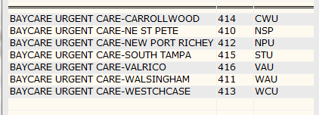

## 5.5 Approvals

|  |  |  |  |
| --- | --- | --- | --- |
| **Testing Phase** | **Date** | **Department** | **Team Member** |
| PH1.0 |  |  |  |
|  |  |  |  |
|  |  |  |  |

# 6. Deployment / Implementation Model

Provide the detail as to how to deploy the solution defined in the IDBB from both the BAYCARE and vendor perspective.

ge_cer_race Table

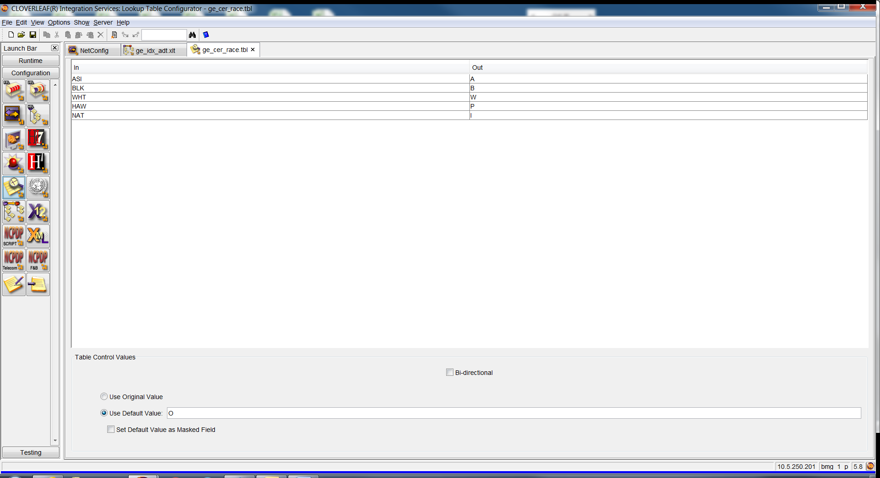

ge_ris_lang

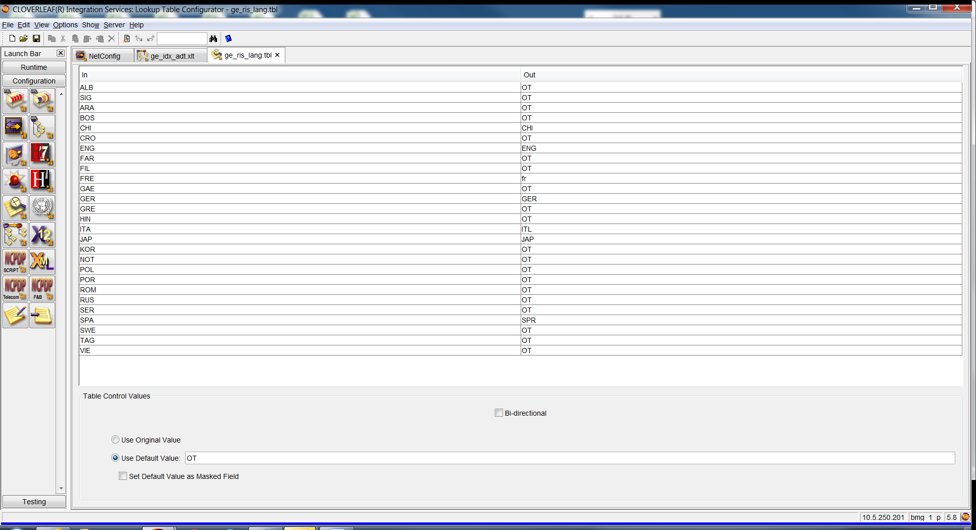

# Appendix A: Risks and Concerns

|  |  |  |  |  |  |  |  |  |
| --- | --- | --- | --- | --- | --- | --- | --- | --- |
| **Project Name** |  |  | | |  |  |  |  |
| **Number** | **Risk / Concern** | **Comment** | **Mitigation** | | |  |  |  |
| RC.2013.1.0 |  |  | |  | |  |  |  |

# Appendix B: Issues List

This is a dynamic list of the open issues related to the IDBB that remain to be solved, including but not limited to TBDs, pending decisions, information needed, conflict awaiting resolution, and the like.

|  |  |  |  |  |  |  |  |  |
| --- | --- | --- | --- | --- | --- | --- | --- | --- |
| **Project Name** |  |  | | |  |  |  |  |
| **Number** | **Issue** | **Comment** | **Fix** | | |  |  |  |
| I.2013.1.0 |  |  | |  | |  |  |  |

* End of document